**Advance Excel Assignment 7**

1. Using Insert Function, give examples of any function available in the different dropdowns present in the function library. For example, AutoSum, Recently Used, Text, Date & Time, etc.

Ans. There are several ways you can insert your functions:  
 1) Formulas tab, Insert Function  
 2) Pressing (Shift + F3)  
 3) Clicking the Insert Function button "fx".  
 4) Typing an equal sign directly into a cell. This method does not display the "Insert Function" dialog box.  
 5) Using the Name Box on the left of the formula bar.

Autosum : If you need to sum a column or row of numbers, let Excel do the math for you. Select a cell next to the numbers you want to sum, click AutoSum on the Home tab, press Enter, and you’re done.

When you click AutoSum, Excel automatically enters a formula to sum the numbers.

Here’s an example. To add the January numbers in this Entertainment budget, select cell B7, the cell immediately below the column of numbers. Then click AutoSum. A formula appears in cell B7, and Excel highlights the cells you’re totaling.

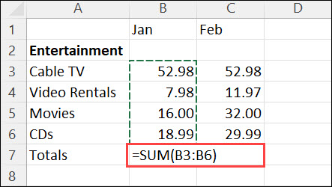

Press Enter to display the result (95.94) in cell B7. You can also see the formula in the formula bar at the top of the Excel window.

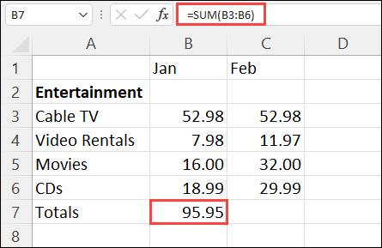

1. What are the different ways you can select columns and rows?

Ans. Select the letter at the top to select the entire column. Or click on any cell in the column and then press Ctrl + Space.

Select the row number to select the entire row. Or click on any cell in the row and then press Shift + Space.

To select non-adjacent rows or columns, hold Ctrl and select the row or column numbers.

1. What is AutoFit and why do we use it?

Ans. We can set column width and row height manually as per our requirement by clicking on column width or row height in the Format option in the cells group on the Home tab.

But sometimes, when we don’t know about the exact width of the column or the height of the row, then we use Autofit in Excel.

Excel’s AutoFit is used to automatically resize cells in a worksheet to accommodate different sized data and avoid manually changing the column width and row height. It automatically adjust the row height or column width.

Autofit Row Height : To adjust the row height automatically.

Autofit Column Width: To adjust the Column Width automatically.

Using the Autofit:

Follow the below steps to use Autofit feature in Excel:

Step 1: Select the column or columns that you want to change.

Step 2: On the Home tab, in the Cells group, click Format.

Step 3: Under Cell Size, click AutoFit Column Width to adjust column width. (To adjust row height, click on Autofit Row height)

Example :

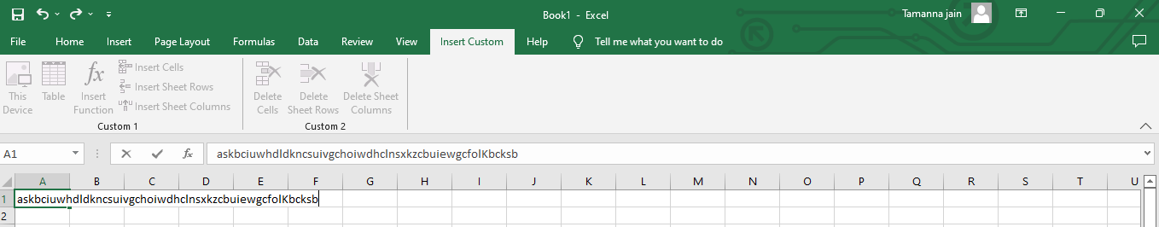

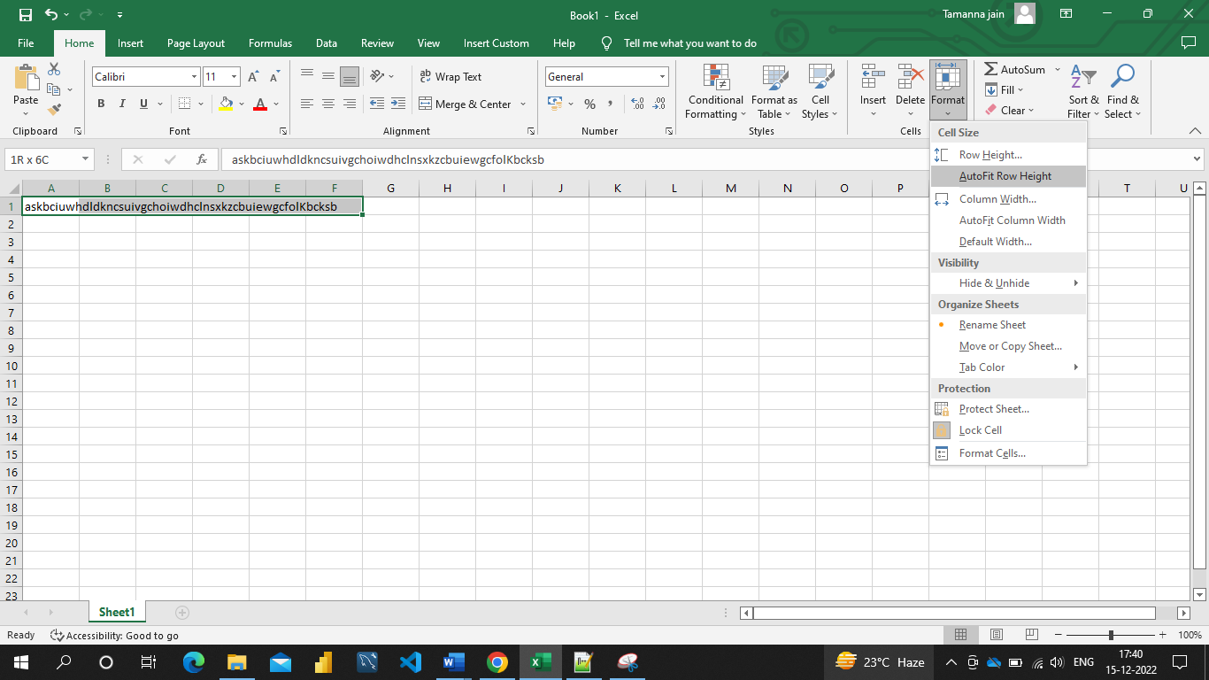

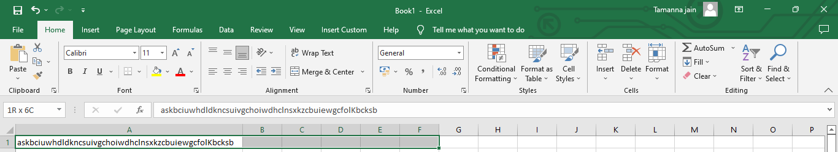

1. How can you insert new rows and columns into the existing table?

Ans. User can use the Resize command in Excel to add rows and columns to a table:

* Click anywhere in the table, and the Table Tools option appears.
* Click Design > Resize Table.

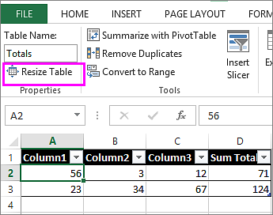

* Select the entire range of cells you want your table to include, starting with the upper-leftmost cell.
* 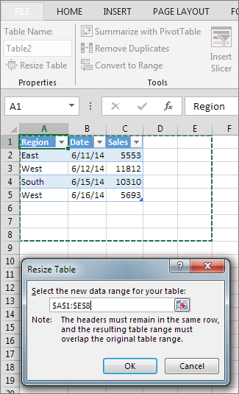In the example shown below, the original table covers the range A1:C5. After resizing to add two columns and three rows, the table will cover the range A1:E8.

1. How do you hide and unhide columns in excel?

Ans. Hide columns

1. Select one or more columns, and then press Ctrl to select additional columns that aren't adjacent.
2. Right-click the selected columns, and then select Hide.

Note: The double line between two columns is an indicator that you've hidden a column.

Unhide columns

1. Select the adjacent columns for the hidden columns.
2. Right-click the selected columns, and then select Unhide.

    Or double-click the double line between the two columns where hidden columns exist.

1. Create an appropriate table within the worksheet and use different functions available in the AutoSum command.

Ans. AutoSum Average Fn :

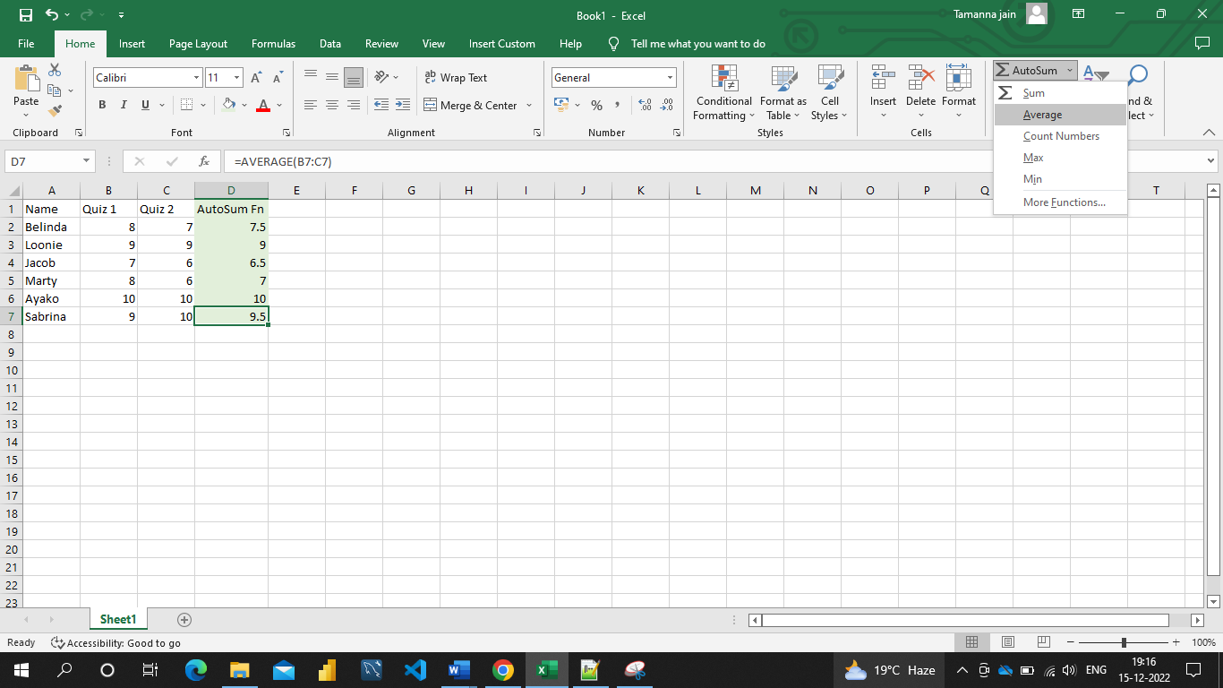

AutoSum Count Numbers Fn :

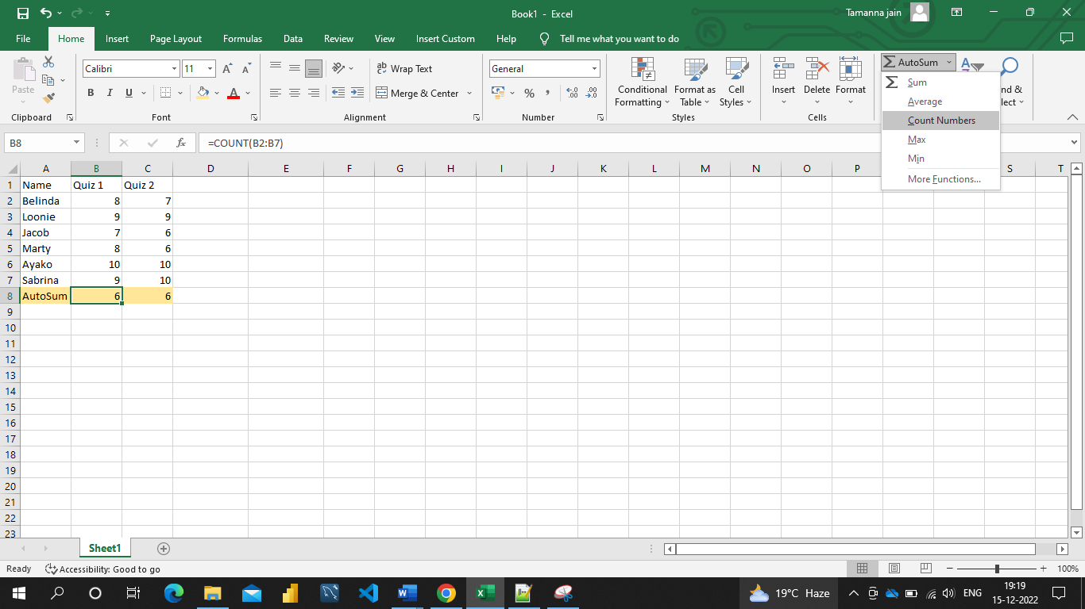

AutoSum Max fn:

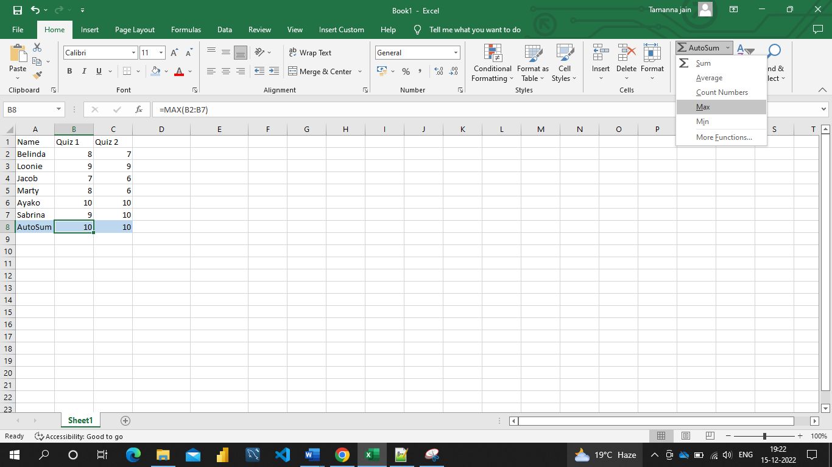

AutoSum Min Fn:

